Name _____________________________ Area of Complex Figures.
- Find the area.
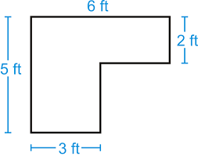
A. 180 ft² The murderer had dark hair.

B. 27 ft² The murder did not have an earring.

C. 21 ft² The murder left an earring behind.

D. 16 ft² The murder broke his/her glasses.
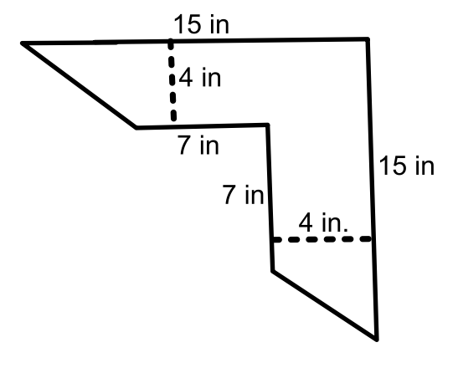
2. Find the area.
A. 120 in² The murderer was a male.

B. 56 in² An earring was found at the scene.

C. 52 in² A short person was seen running from the
scene.

D. 88 in² Strands of dark hair were found on the victim.
3. Find the area.
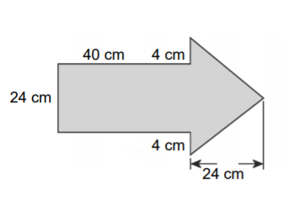
A. 1344 cm² The victim saw his reflection in the murder’s glasses

B. 1728 cm² The murder has a mustache

C. 1248 cm² A pair of glasses were found at the scene

D. 3840 cm² The light hair person was seen sneaking away
4. Find the area.
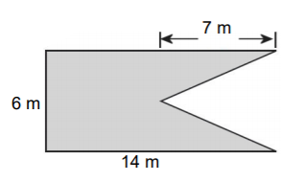
- 126 m² The murder’s dark hair was hidden
under his/her hat.

- 42 m² The murder was wearing high heels.

- 84 m² The murder has a diamond earring.

- 63 m² A witness saw a tall person running
away from the scene.

5. Find the area of the shaded part.
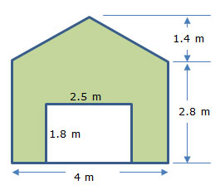
A. 14 m² A blond piece of hair was found at the
scene.

B. 12.3 m² The murderer was wearing glasses.

C. 9.5 m² The murderer had a beard.

D. 15.68 m² The murderer had hoop earrings.
